# PRACTICAL – 1

# Date: 11-01-2022

AIM: To Simulate M-PSK and M-QAM Modulation Techniques with the help of MATLAB software where M= 4, 8, 16, 32, 64. Also plot the constellation diagram for each M.

Apparatus: MATLAB software

## THEORY:

## Phase Shift Keying

**Phase Shift Keying (PSK)** is the digital modulation technique in which the phase of the carrier signal is changed by varying the sine and cosine inputs at a particular time. PSK technique is widely used for wireless LANs, bio-metric, contactless operations, along with RFID and Bluetooth communications.

### Binary Phase Shift Keying (BPSK)

This is also called as **2-phase PSK** (or) **Phase Reversal Keying**. In this technique, the sine wave carrier takes two phase reversals such as 0° and 180°.

BPSK is basically a DSB-SC (Double Sideband Suppressed Carrier) modulation scheme, for message being the digital information.

**Quadrature Phase Shift Keying (QPSK)**

ASK, FSK and BPSK transmit one bit per symbol and hence carrier is assumed to have one of the two possible states to transmit 1 or 0.

Quadrature Phase Shift Keying (QPSK) is a form of Phase Shift Keying which transmits two bits per symbol.

Since it transmits two bits per symbol there are four possible combinations and thus there is four different phases.

* For 𝝿/4 QPSK, the four different phases are 45, 135, 225, 315.
* QPSK symbols are not represented by 0 or 1 but it is represented as 00, 01, 10 and 11.
* QPSK carry twice as much information as ordinary PSK using the same bandwidth.
* QPSK is used for satellite transmission of MPEG2 video, cable modems, videoconferencing, cellular phone systems, and other forms of digital communication over an RF carrier.

**Quadrature Amplitude Modulation (QAM)**

Quadrature Amplitude Modulation, QAM is a form of modulation that is a combination of phase modulation and amplitude modulation. The QAM scheme represents bits as points in a quadrant grid know as a constellation map. Constellation Map

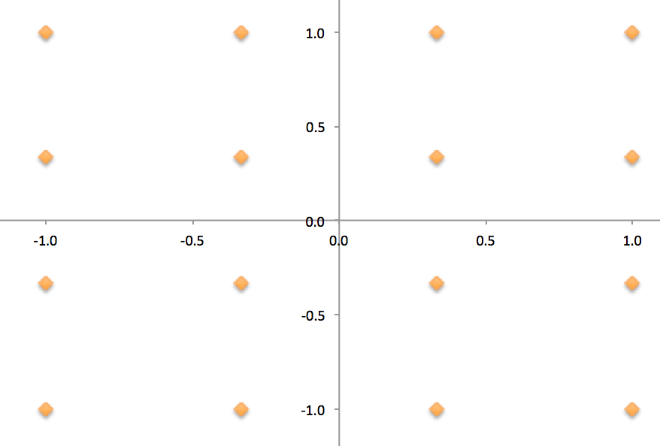

**Constellation map of 16-QAM**

**Phase Modulation**

* Represents bits by changing the angle of a wave.
* An example of Phase Modulation is QPSK-4.

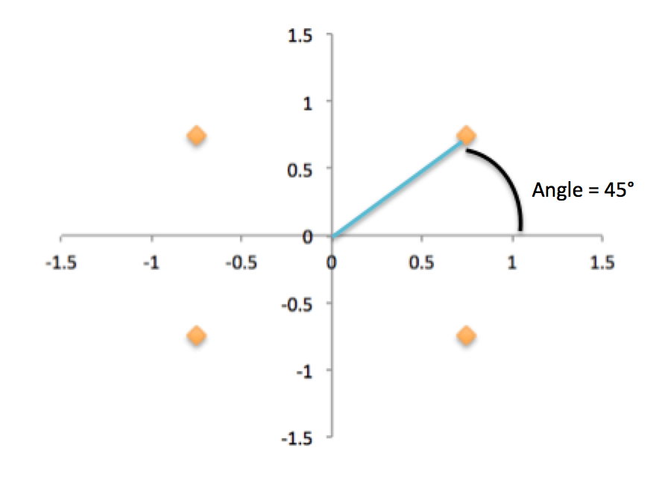

* As seen above, QPSK can have four different phase changes as four different angles.
* Is the angle of the constellation point.

## QAM modulator

The QAM modulator essentially follows the idea that can be seen from the basic QAM theory where there are two carrier signals with a phase shift of 90° between them. These are then amplitude modulated with the two data streams known as the I or In-phase and the Q or quadrature data streams. These are generated in the baseband processing area.

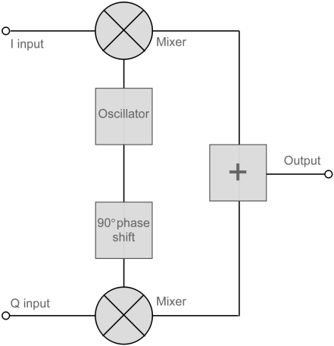

The two resultant signals are summed and then processed as required in the RF signal chain, typically converting them in frequency to the required final frequency and amplifying them as required.

## QAM demodulator

The QAM demodulator is very much the reverse of the QAM modulator.

The signals enter the system, they are split and each side is applied to a mixer. One half has the in-phase local oscillator applied and the other half has the quadrature oscillator signal applied.

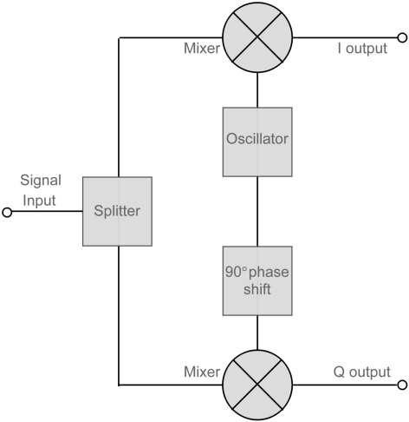

The basic modulator assumes that the two quadrature signals remain exactly in quadrature.

A further requirement is to derive a local oscillator signal for the demodulation that is exactly on the required frequency for the signal. Any frequency offset will be a change in the phase of the local oscillator signal with respect to the two double sideband suppressed carrier constituents of the overall signal.

Systems include circuitry for carrier recovery that often utilizes a phase locked loop - some even have an inner and outer loop. Recovering the phase of the carrier is important otherwise the bit error rate for the data will be compromised.

## ALGORITHM:

**STEP1:** Get the image matrix using “**imread**” and convert the image matrix to 1-D matrix.

**STEP2:** Convert the 1-D matrix to binary column matrix

**STEP3:** Modulate the obtained binary column matrix using inbuilt functions for different order of modulation **(qammod /qamdemod).**

**STEP4:** Demodulate received input using inbuilt functions **(qamdemod /pskdemod).**

**STEP5:** Reshape the demodulated matrix into matrix having 8 rows, after that convert this matrix to decimal using uint8 and bi2dec.

**STEP6:** Reshape the output matrix to 256 x 256 and plot the constellation diagram.

## MATLAB CODE:

**1. M-QAM**

|  |
| --- |
| clc;  clear all;  close all;    %%  %Taking Image as input.  image = imread('cameraman.tif');  %showing image to screen  figure('name', 'transmitted')  imshow(image);    %%  %Input matrix to 1-D vector.  imageR = image(:);  %Decimal matrix to Binary matrix  binary = de2bi(imageR);  %Reshaping column matrix.  binaryC = binary(:);  %Performing QAM modulation.  mod = qammod(binaryC,4);  %Performing QAM demodulation.  demod = qamdemod(mod,4);  %Reshaping  f = reshape(demod,[65536,8]);  %Double to uint8  g = uint8(f);  %Binary to decimal conversion  h = bi2de(g);  %Reshaping into pixel matrix.  received = reshape(h,256,256);  %Output  figure('name', 'received');  imshow(received);  scatterplot(mod);  scatterplot(demod); |

**2. M-PSK**

|  |
| --- |
| clc;  clear all;  close all;    %%  %Taking Image as input.  image = imread('cameraman.tif');  %showing image to screen  figure('name', 'transmitted')  imshow(image);    %%  %Input matrix to 1-D vector.  imageR = image(:);  %Decimal matrix to Binary matrix  binary = de2bi(imageR);  c = double(binary);  %Reshaping column matrix.  binaryC = c(:);  %Performing QAM modulation.  mod = pskmod(binaryC,4);  %Performing QAM demodulation.  demod = pskdemod(mod,4);  %Reshaping  f = reshape(demod,[65536,8]);  %Double to uint8  g = uint8(f);  %Binary to decimal conversion  h = bi2de(g);  %Reshaping into pixel matrix.  received = reshape(h,256,256);  %Output  figure('name', 'received');  imshow(received);  scatterplot(mod);  scatterplot(demod); |

## OUTPUTS:

## 

## Plots for 4-QAM

## 

## Plots for 8-QAM

## 

## Plots for 16-QAM

## 

## Plots for 32-QAM

## 

## Plots for 64-QAM

## 

## Plots for 4-PSK

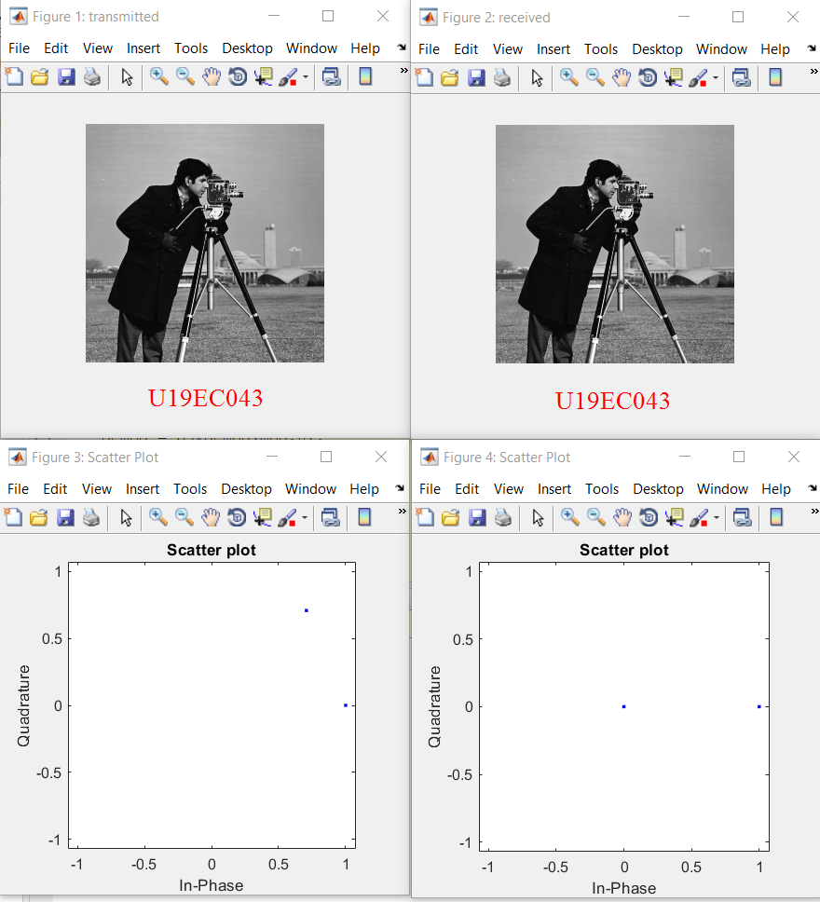

## Plots for 8-PSK

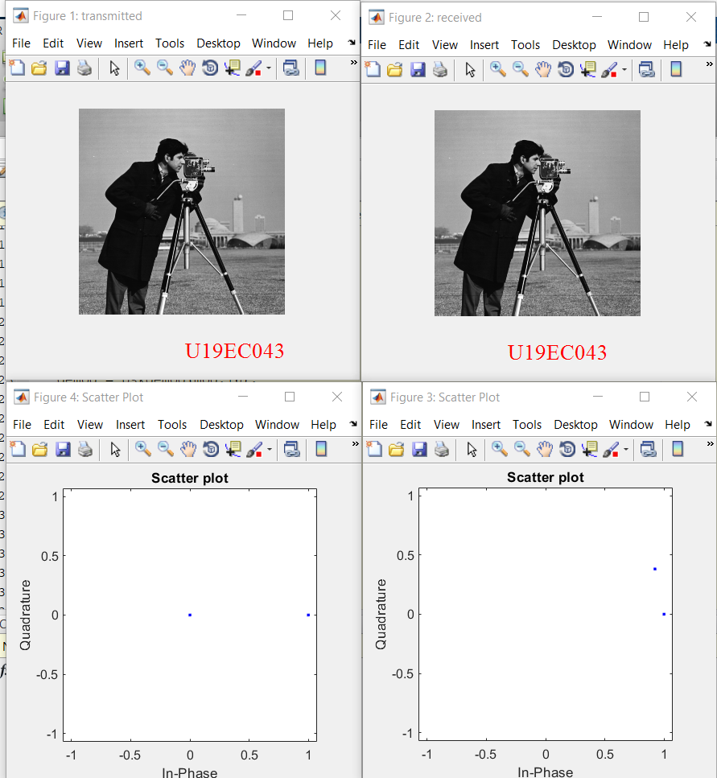

## Plots for 16-PSK

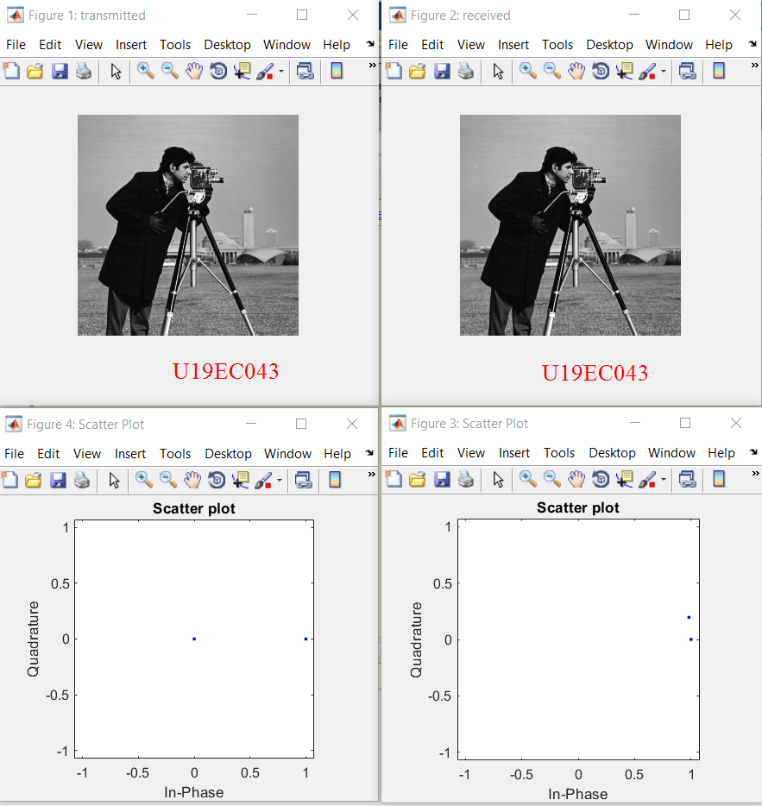

## Plots for 32-PSK

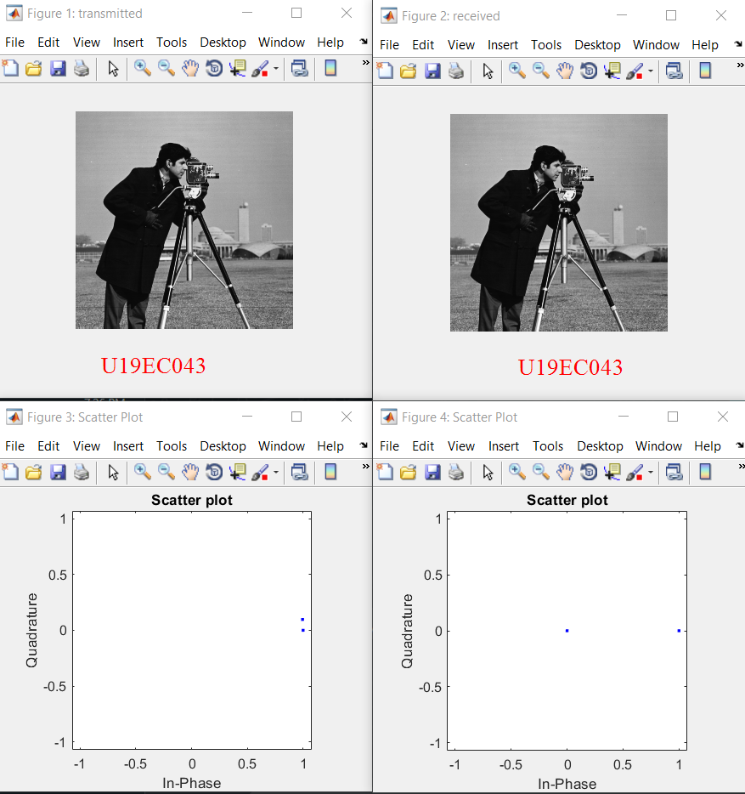

## Plots for 64-PSK

# CONCLUSION:

In this experiment, we simulated M-PSK and M-QAM Modulation Techniques with the help of MATLAB software for M= 4, 8, 16, 32, 64 and plotted the constellation diagram.